Web & Mobile Technology

[Assignment One]

**Content:**

* **What is CSS**
* **CSS Color**
* **CSS FONTS**
* **CSS BORDERS**
* **CSS MARGINS**
* **CSS PADING**
* **USE OF CSS**
* **ADVANTAGE OF CSS**
* **DISADVANTAGE OF CSS**
* **HTML TABLE**

2021

**Vanshika Bagri(04901032018)**

**B.Tech. (Information Technology)**

03/02/2021

# **WHAT IS CSS?**

Cascading Style Sheets (CSS) is a simple mechanism for adding style (e.g., fonts, colors, and spacing) to Web documents.

**CSS COLOR:**

Colors are specified using predefined color names, or RGB, HEX, HSL, RGBA, HSLA values.

In CSS, a color can be specified by using a predefined color name such as :

Tomato, Orange, DodgerBlue etc.

Example:

<!DOCTYPE html>

<html>

<body>

<h1 style="background-color:Tomato;">Tomato</h1>

<h1 style="background-color:Orange;">Orange</h1>

<h1 style="background-color:DodgerBlue;">DodgerBlue</h1>

</body>

</html>

The following code will make the heading (h1) of the mentioned color.

## **CSS Background Color:**

You can set the background color for HTML elements:

Example:

<body>

<html>

<h1 style="background-color:DodgerBlue;">Hello World</h1>

</body>

</html>

The following code will change the background color of the heading “Hello World” from default to DodgerBlue.

## 

## **CSS Text Color:**

You can set the color of text:

Example:

<!DOCTYPE html>

<html>

<body>

<h3 style="color:Tomato;">Hello World</h3>

</body>

</html>

The following code will change the color of the text of heading “Hello World” from default to Tomato.

## **CSS Border Color:**

You can set the color of borders:

Example:

<!DOCTYPE html>

<html>

<body>

<h1 style="border: 2px solid Tomato;">Hello World</h1>

</body>

</html>

The following code will change the color of the border (of width 2px and type solid) from default to Tomato.

## **CSS Color Values:**

In CSS, colors can also be specified using RGB values, HEX values, HSL values, RGBA values, and HSLA values:

Example:

Same as color name "Tomato":

**rgb (255, 99, 71)**

**#ff6347**

The following rgb values and color code can also be in place of specifying the color name and will produce the same color.

# **CSS Fonts:**

Using a font that is easy to read is important. The font adds value to your text. It is also important to choose the correct color and text size for the font.

## **Generic Font Families:**

In CSS there are five generic font families:

1. Serif fonts have a small stroke at the edges of each letter. They create a sense of formality and elegance.
2. Sans-serif fonts have clean lines (no small strokes attached). They create a modern and minimalistic look.
3. Monospace fonts - here all the letters have the same fixed width. They create a mechanical look.
4. Cursive fonts imitate human handwriting.
5. Fantasy fonts are decorative/playful fonts.

All the different font names belong to one of the generic font families.

## **The CSS font-family Property:**

In CSS, we use the font-family property to specify the font of a text.

If the font name is more than one word, it must be in quotation marks, like: "Times New Roman".

Example:

<!DOCTYPE html>

<html>

<head>

<style>

.p1 {

font-family: "Times New Roman", Times, serif;

}

</style>

</head>

<body>

<h1>CSS font-family</h1>

<p class="p1">This is a paragraph, shown in the Times New Roman font.</p>

</body>

</html>

The following code will change the font of the paragraph p1 from default to the mentioned font-family i.e. Times New Roman.

## **Font Style:**

The font-style property is mostly used to specify italic text.

This property has three values:

* normal - The text is shown normally
* italic - The text is shown in italics
* oblique - The text is "leaning" (oblique is very similar to italic, but less supported)

Example:

<!DOCTYPE html>

<html>

<head>

<style>

p.normal {

font-style: normal;

}

p.italic {

font-style: italic;

}

p.oblique {

font-style: oblique;

}

</style>

</head>

<body>

<p class="normal">This is a paragraph in normal style.</p>

<p class="italic">This is a paragraph in italic style.</p>

<p class="oblique">This is a paragraph in oblique style.</p>

</body>

</html>

The following code will show the paragraphs with their mentioned font styles.

## **Font Size:**

The font-size property sets the size of the text.

The font-size value can be an absolute, or relative size.

Absolute size:

* Sets the text to a specified size
* Does not allow a user to change the text size in all browsers (bad for accessibility reasons)
* Absolute size is useful when the physical size of the output is known

Relative size:

* Sets the size relative to surrounding elements
* Allows a user to change the text size in browsers

Example:

<!DOCTYPE html>

<html>

<head>

<style>

h1 {

font-size: 40px;

}

h2

{

font-size: 1.875em; /* 30px/16=1.875em */

}

</style>

</head>

<body>

<h1>This is heading 1</h1>

<h2>This is heading 2</h2>

</body>

</html>

The h1 heading will have a font-size of 40px and h2 will have a font-size of 1.875em which is approximately 30px.

We can set the font size using pixel, em or percentage.

# **CSS Borders:**

The CSS border properties allow you to specify the style, width, and color of an element's border.

## **CSS Border Style:**

The border-style property specifies what kind of border to display.

The following values are allowed:

* dotted - Defines a dotted border
* dashed - Defines a dashed border
* solid - Defines a solid border
* double - Defines a double border
* groove - Defines a 3D grooved border. The effect depends on the border-color value
* ridge - Defines a 3D ridged border. The effect depends on the border-color value
* inset - Defines a 3D inset border. The effect depends on the border-color value
* outset - Defines a 3D outset border. The effect depends on the border-color value
* none - Defines no border
* hidden - Defines a hidden border

The border-style property can have from one to four values (for the top border, right border, bottom border, and the left border).

Example:

<!DOCTYPE html>

<html>

<head>

<style>

p.dotted {border-style: dotted;}

p.dashed {border-style: dashed;}

p.solid {border-style: solid;}

p.double {border-style: double;}

p.groove {border-style: groove;}

p.ridge {border-style: ridge;}

p.inset {border-style: inset;}

p.outset {border-style: outset;}

p.none {border-style: none;}

p.hidden {border-style: hidden;}

p.mix {border-style: dotted dashed solid double;}

</style>

</head>

<body>

<h2>The border-style Property</h2>

<p>This property specifies what kind of border to display:</p>

<p class="dotted">A dotted border.</p>

<p class="dashed">A dashed border.</p>

<p class="solid">A solid border.</p>

<p class="double">A double border.</p>

<p class="groove">A groove border.</p>

<p class="ridge">A ridge border.</p>

<p class="inset">An inset border.</p>

<p class="outset">An outset border.</p>

<p class="none">No border.</p>

<p class="hidden">A hidden border.</p>

<p class="mix">A mixed border.</p>

</body>

</html>

The following code displays different style of borders as specified in different paragraphs.

## **CSS Border Width:**

The border-width property specifies the width of the four borders.

The "border-width" property does not work if it is used alone.

Always specify the "border-style" property to set the borders first.

The width can be set as a specific size (in px, pt, cm, em, etc) or by using one of the three predefined values: thin, medium, or thick:

Example:

<!DOCTYPE html>

<html>

<head>

<style>

p.one {

border-style: solid;

border-width: 5px;

}

p.two {

border-style: solid;

border-width: medium;

}

</style>

</head>

<body>

<h2>The border-width Property</h2>

<p>This property specifies the width of the four borders:</p>

<p class="one">Some text.</p>

<p class="two">Some text.</p>

</body>

</html>

The following code sets the paragraph with class “one” with a solid border of width of 5px and the paragraph with class “two” with a solid border of width ‘medium’.

## **CSS Border Color:**

The border-color property is used to set the color of the four borders.

If border-color is not set, it inherits the color of the element.

Example:

<!DOCTYPE html>

<html>

<head>

<style>

p.one {

border-style: solid;

border-color: red;

}

</style>

</head>

<body>

<p class="one">A solid red border</p>

</body>

</html>

The following code generates a border of color red and style solid around the paragraph p.

## 

## **CSS Margins:**

The CSS margin properties are used to create space around elements, outside of any defined borders.

## **Margin - Individual Sides**

CSS has properties for specifying the margin for each side of an element:

* margin-top
* margin-right
* margin-bottom
* margin-left

All the margin properties can have the following values:

* auto - the browser calculates the margin
* *length* - specifies a margin in px, pt, cm, etc.
* *%* - specifies a margin in % of the width of the containing element
* inherit - specifies that the margin should be inherited from the parent element

Example:

<!DOCTYPE html>

<html>

<head>

<style>

div {

border: 1px solid black;

margin-top: 100px;

margin-bottom: 100px;

margin-right: 150px;

margin-left: 80px;

background-color: lightblue;

}

</style>

</head>

<body>

<div>Hello.</div>

</body>

</html>

The following code generates a div element which has a top margin of 100px, a right margin of 150px, a bottom margin of 100px, and a left margin of 80px.

## 

## **Shorthand Property:**

To shorten the code, it is possible to specify all the margin properties in one property.

If the margin property has four values:

Example:

margin: 25px 50px 75px 100px;

* top margin is 25px
* right margin is 50px
* bottom margin is 75px
* left margin is 100px

Example:

<!DOCTYPE html>

<html>

<head>

<style>

div {

border: 1px solid black;

margin: 25px 50px 75px 100px;

background-color: lightblue;

}

</style>

</head>

<body>

<div>Hello</div>

<hr>

</body>

</html>

The following code generates a div element which has a top margin of 25px, a right margin of 50px, a bottom margin of 75px, and a left margin of 100px

## **CSS Padding:**

The CSS padding properties are used to generate space around an element's content, inside of any defined borders.

## **Padding - Individual Sides**

CSS has properties for specifying the padding for each side of an element:

* padding-top
* padding-right
* padding-bottom
* padding-left

All the padding properties can have the following values:

* *length* - specifies a padding in px, pt, cm, etc.
* *%* - specifies a padding in % of the width of the containing element
* inherit - specifies that the padding should be inherited from the parent element

Example:

<!DOCTYPE html>

<html>

<head>

<style>

div {

border: 1px solid black;

background-color: lightblue;

padding-top: 50px;

padding-right: 30px;

padding-bottom: 50px;

padding-left: 80px;

}

</style>

</head>

<body>

<div>Hello</div>

</body>

</html>

The following code generates a div element which has a top padding of 50px, a right padding of 30px, a bottom padding of 50px, and a left padding of 80px.

**Shorthand Property:**

To shorten the code, it is possible to specify all the padding properties in one property.

If the padding property has four values:

Example:

padding: 25px 50px 75px 100px;

* top padding is 25px
* right padding is 50px
* bottom padding is 75px
* left padding is 100px

Example:

<!DOCTYPE html>

<html>

<head>

<style>

div {

border: 1px solid black;

padding: 25px 50px 75px 100px;

background-color: lightblue;

}

</style>

</head>

<body>

<div>Hello.</div>

</body>

</html>

The following code generates a div element which has a top padding of 25px, a right padding of 50px, a bottom padding of 75px, and a left padding of 100px.

**Use of CSS:**

Before CSS, nearly all presentational attributes of HTML documents were contained within the HTML markup. All font colors, background styles, element alignments, borders and sizes had to be explicitly described, often repeatedly, within the HTML. CSS let's authors move much of that information to another file, the style sheet, resulting in considerably simpler HTML.

**Advantages of CSS:**

* CSS saves time − You can write CSS once and then reuse the same sheet in multiple HTML pages. You can define a style for each HTML element and apply it to as many Web pages as you want.
* Easy maintenance − To make a global change, simply change the style, and all elements in all the web pages will be updated automatically.
* Global web standards − Now HTML attributes are being deprecated and it is being recommended to use CSS. So it's a good idea to start using CSS in all the HTML pages to make them compatible with future browsers.
* Platform Independence − The Script offers consistent platform independence and can support latest browsers as well.

**Disadvantages of CSS:**

* Fragmentation

CSS renders different dimensions with each browser.

* Different Levels

There are different levels to CSS: CSS; CSS 2; CSS 3. This has been confusing for developers and browsers

**HTML Table:**

**<!DOCTYPE html>**

**<html lang="en">**

**<head>**

**<meta charset="UTF-8">**

**<meta name="viewport" content="width=device-width, initial-scale=1.0">**

**<title>Document</title>**

**<style>**

**table, th, td {**

**border: 3px solid black;**

**background-color: LightPink;**

**font-size: 25px;**

**}**

**td{**

**text-align: center;**

**vertical-align: middle;**

**}**

**h2{**

**text-align: center;**

**font-size: 30px;**

**}**

**h1{**

**text-align: center;**

**color: MidnightBlue;**

**font-family:sans-serif;**

**}**

**body {**

**background-color: Lavender;**

**}**

**</style>**

**</head>**

**<body>**

**<h1><u>Time Table</u></h1><h2>Information Technology</h2><h2>2018-2022</h2>**

**<table width="100%"**

**height ="600" >**

**<tr>**

**<th>Time</th>**

**<th>Monday</th>**

**<th>Tuesday</th>**

**<th>Wednesday</th>**

**<th>Thursday</th>**

**<th>Friday</th>**

**</tr>**

**<tr>**

**<th>9:00-10:00</th>**

**<td>WMT</td>**

**<td>NP</td>**

**<td>---</td>**

**<td>---</td>**

**<td>NP</td>**

**</tr>**

**<tr>**

**<th>10:00-11:00</th>**

**<td>WMT</td>**

**<td colspan="2">NP</td>**

**<td>WMT</td>**

**<td>AI</td>**

**</tr>**

**<tr>**

**<th>11:00-12:00</th>**

**<td rowspan="2">NP Lab</td>**

**<td rowspan="2">WMT Lab</td>**

**<td rowspan="2">CD</td>**

**<td>WMT</td>**

**<td rowspan="2">AI Lab</td>**

**</tr>**

**<tr>**

**<th>12:00-1:00</th>**

**<td>CC</td>**

**</tr>**

**<tr>**

**<th>1:00-2:00</th>**

**<td>L</td>**

**<td>U</td>**

**<td rowspan="2">CC Lab</td>**

**<td>C</td>**

**<td>H</td>**

**</tr>**

**<tr>**

**<th>2:00-3:00</th>**

**<td>CC</td>**

**<td>AI</td>**

**<td rowspan="2">CD</td>**

**<td>EE</td>**

**</tr>**

**<tr>**

**<th>3:00-4:00</th>**

**<td>CC</td>**

**<td>AI</td>**

**<td>CC</td>**

**<td rowspan="2">CD Lab</td>**

**</tr>**

**<tr>**

**<th>4:00-5:00</th>**

**<td>AI</td>**

**<td colspan="2">EE</td>**

**<td>---</td>**

**</tr>**

**</table>**

**</body>**

**</html>**

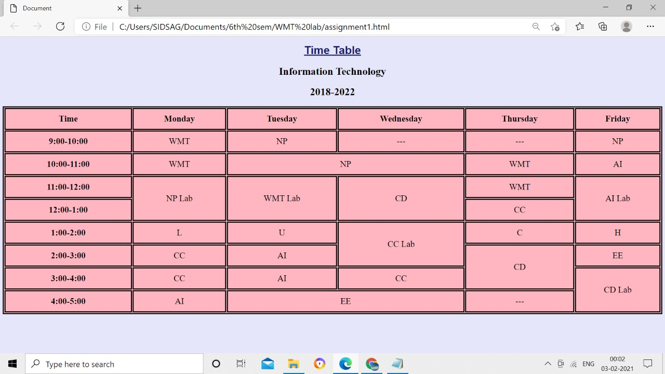

**T****HANkS!!**